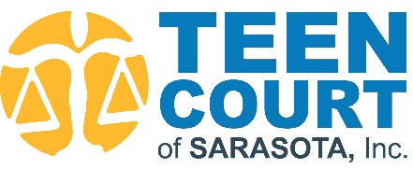
THE 2023 JACK BYERS MEMORIAL GOLF TOURNAMENT
Friday, May 12, 2023, 8:30 a.m.
Palm Aire Country Club, 5601 Country Club Way, Sarasota, FL 34243
Shotgun Sponsorship Commitment Form

Please submit this form by Friday, April 1, 2023, to receive full sponsor benefits.
Sponsor Name:
*Exactly as you would like it to appear on any marketing materials
Contact Name:
Address:
City: State: Zip:
Phone: Email:
Transformation $5,000 (two foursomes, signage at registration, four tee signs, opportunity to include promo material in grab bag, feature on website and social media)
Positive Redirection $3,000 (one foursome, signage at shotgun, two tee signs, opportunity to include promo material in grab bag, social media recognition)
Outreach $1,500 (two golfers, one tee sign, website and social media feature and opportunity to include promo material in grab bag)
Succeed $500 (one golfer, one tee sign, logo on website and social media platforms)
Tee Sign $150 x
Foursome $800 x Individual Golfer $200 x
Raffle ticket options:
☐ Fairway $20 x _______ ($20/ea.)
☐ Birdie $50 x _______ (5 raffle tickets for $50)
☐ Hole-In-One $100 x _______ (10 raffle tickets for $100)
☐ Mulligans $10 x _______ ($10/ea., limit 2)

I am unable to participate as a sponsor, but would like to make a tax-deductible donation of $
Total enclosed $ Check No.
MC/VISA/AMEX Credit Card # Exp. Date
CVV# Signature
Return completed form to: Lori@SarasotaTeenCourt.org
Mail completed form to: Teen Court of Sarasota, Inc. | P.O. Box 48927 | Sarasota, FL 34230
Fax completed form to: (941) 861-8461
Thank you for your support!
Your contribution is tax deductible minus cost of goods or services.
The Federal Tax ID for Teen Court of Sarasota, Inc. is 65-0108304.

